DATA FLOW DIAGRAM FOR LABOUR ID SYSTEM

CONTEXT LEVEL

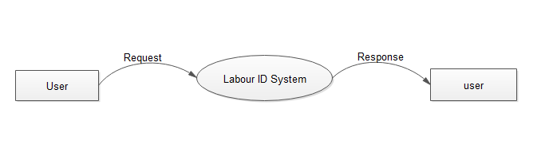

LEVEL1- ADMIN

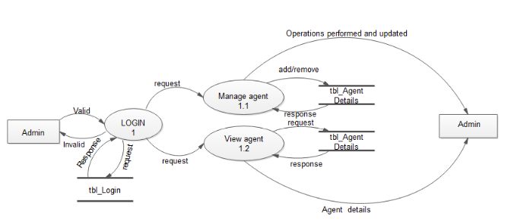

LEVEL1- AGENT

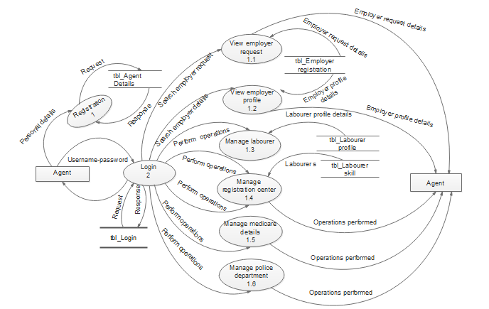

LEVEL1- POLICE DEPARTMENT

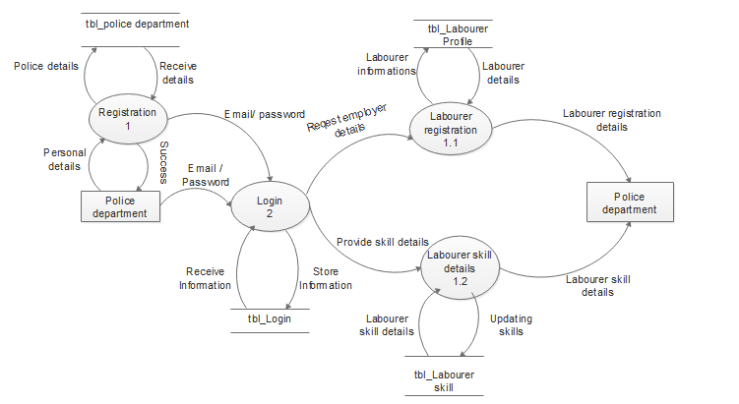

LEVEL1- EMPLOYER

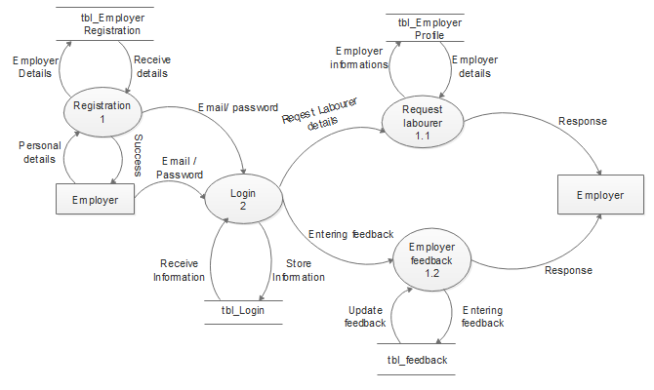

LEVEL1- REGISTRATION CENTER

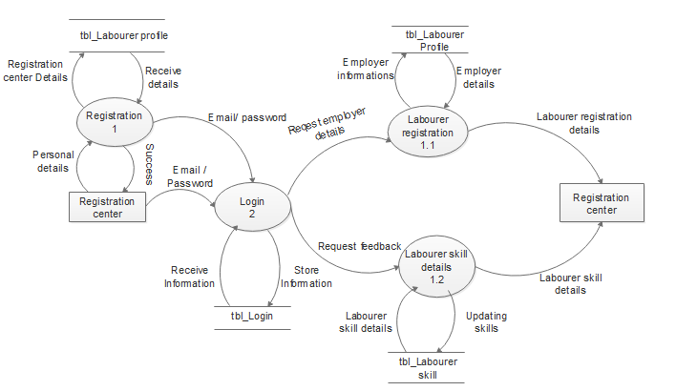

LEVEL1- MEDICARE

